LA Tech Demons / Team #5

Christopher Rodriguez, Nick Harrington, Will Solito, Sarah Ball, Chris Sanders, and Charles Pickett

List of completed tasks

* Players ACTUALLY do damage to enemies (bug fix)
* Enemies show health when damaged
* ANIMATIONS!!!
* Items can be picked up now
* Changed how maps and layers are implemented (should be a lot cleaner)
* Buildings are now a thing! Text files define what they should spawn and where they should spawn it, plus where colliders should be drawn.
* Multiple bug fixes.

List of future tasks (that we hope to complete in the immediate future)

* Finish GUI (I have some of the groundwork done but none of the implementation). This is going to include health, inventory, and tool tips.
* Implement off hand items. To be honest, I may just replace off hand items with relics that give you an aura of protection. This will be easier to implement because I do not have to render all those animations.
* 3D modelling must commence. Graphics are getting critical at this point.
* I guess it’s time to begin work on the levels and quests.
* We need to actually design enemies, items, buildings, tiles, and everything else. So far, everything has been an example of how we are eventually going to do it. Now comes the time to actually do it.
* Make enemies only follow when you enter their building. Keep track of when a building is cleared.

Issues

* Frustration everywhere. It’s really disheartening when you spend a solid hour on a piece of code and it ends up malfunctioning. Redesigning over and over can really wear on you. Also, thinking about everything that needs to be done in such a short time can be daunting.
* At this stage in the process, design flaws jump at you. It comes to the point where I just have to keep programming instead of going back and rebuilding the whole project. On the other hand, good design ideas are starting to be rewarded. Finding that 90% of everything you need for the new class has already been done and you just need to call a few methods is a great feeling.
* Time is ticking down. I am sort of scared that we basically have 2 to 3 weeks left of development for this game must be done. There is a lot more to do and it all has to look pretty.

Attendance Sheet

|  |  |  |  |  |
| --- | --- | --- | --- | --- |
|  |  | 3/21/2016 | 3/23/2016 | 4/4/2016 |
|  | Nick Harrington | P | P | P |
|  | Will Solito | P | P | P |
|  | Sarah Ball | P | P | P |
|  | Charles Pickett | P | P | P |
|  | Christopher Rodriguez | P | P | P |
|  | Chris Sanders | P | P | P |
|  |  |  |  |  |
| P | Present |  |  |  |
| A | Absent |  |  |  |
| E | Absent w/ excuse |  |  |  |

Class Diagram (UNFINISHED)

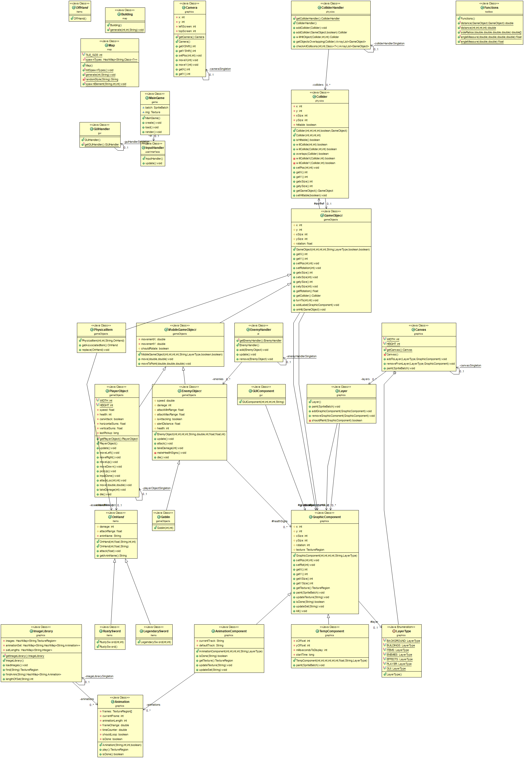

Final Game Idea

Defeat the Four Horsemen of the Apocalypse to save humanity. On every Horseman’s domain, you will find relics you and weapons to assist you in your crusade against evil. Once you beat back enough of the hellish armies of a Horseman, you must defeat that Horseman to progress to the next servant of evil.

Game Map

The game will be randomly generated. There will be four levels: Famine, Plague, War, and Death. Each level will have unique enemies and items.